**MIT – Beat the Pandemic**

**ChainFact**

**COVID-19 Fake news:**

Some of fake news about COVID 19

* Multiple Facebook posts shared a list of foods and contaminated locations in Australia due to coronavirus.
* Rinsing mouth with saltwater to prevent infection from coronavirus but real fact is saline water will kill the virus.
* Posts about spread of coronavirus by eating meat.
* Tweets about warning people to not open their doors to strangers which were circulating in New Jersey, UK, France.
* Advertisements from companies to sell immunity boosting products in order to stop the virus spread.
* Integration of coronavirus news spread to 5G technology evolution.
* Posts stating about not to by medical testing kits for COVID-19 as government didn’t approve them.

**Cause of Spread:**

Untrue statements allure most people’s interest and strong feelings such as surprise, disgust, etc. Almost 60% of the global population, uses internet in regular basis. The probability to fake people with a fake news is quite high. If a specific sector of public follows a fake news, the chance to travel further is faster than the ordinary news.

**Tweets and News about President Trump:**

1. News on CNN

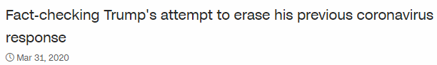

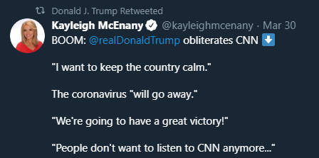

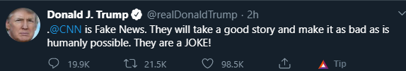

Most believed tweet:

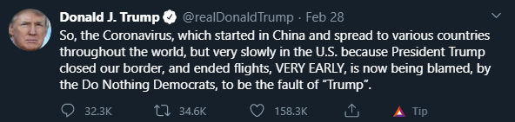

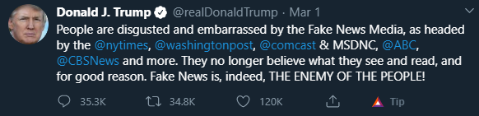

From the observation of tweets from President Donald Trump, around 1 out of 25 tweets is against news channels and negative about actions towards coronavirus.

**Why to fix this issue?**

People believe that the posts that they share are true and they trust the news. Meanwhile, most of the internet population think that a news from a reputed resource will be correct and reliable. There is a lack of further research in these criteria. According a proverb “Look before you leap”, everyone should analyze a fact before sharing to others.

But, relying on research alone won’t benefit the world because it consumes more time as well as effort. Hence, there is a need of some common platform to interact with others and access the news. Using ChainFact, the work will be refined to people as authorized personnel will rate a news as correct or incorrect, so the users can utilize proper information and get rewarded for voting the information.